CIS 601 Quiz 2
Name: | TUId (4 digits) _ _ _ _

Q1 (2 points): Draw histograms for the following images:

 |  | 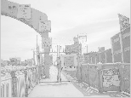 | 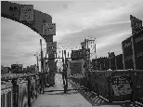


Q2 (2 points) Power Law (g → Cg^{γ}): determine γ (C=1) used for the following transformations of the left image:

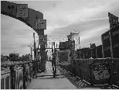 | 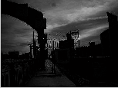 γ= | γ= | γ=

Q3(3 points + 1 bonus): Write a MATLAB function that transforms a gray level image img to a bi-color (black white) image using the mean gray value as threshold.
Bonus: extend the function such that it takes a threshold value T as optional input parameter which overrides the mean.

function [imgOut, Tout] = meanThreshold(imgIn)
(use back side)

Q4 (3 points): How does the function F: [0,1] →[0,1], imgA=F(imgB) look that transforms an image imgA with histogram A to an image imgB with histogram B ? (assume the ideal, continuous case)
Histogram A | Transf.: [0,1]→[0,1] | Histogram B

