QUIZ #4 , CIS68
NAME (printed):
The following diagram shows a single linked list.  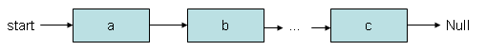  What’s the order of magnitude to add an element at the FIRST position ? O(__)  What’s the order of magnitude to add an element at the LAST position ? O(__)  What’s the order of magnitude to add an element at the 2nd position ? O(__) | 3
Same list given again. Please update the data structure (adding links and references in the diagram) in a way that adding and removal of the last element can be done in O(1). | 2
The following list is a circular list, i.e. every element has exactly one successor.  Let’s assume the list has 3 elements, referenced by ‘a’, ‘b’, and ‘c’. Since b is a’s successor, we can say: b = a.next.  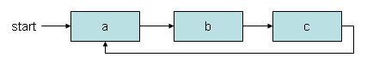  Please fill in the references (e.g. ‘start’, ‘a’, ‘b’, ‘c’) in the following statements:  - a.next.next.next = __  - c.next = __  - start.next.next.next = __ | 3
Now we look at a DOUBLE LINKED CIRCULAR LIST. In a double linked list, nodes have a successor (.next) and a predecessor (.previous).  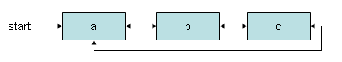  Please fill in the references (e.g. ‘start’, ‘a’, ‘b’, ‘c’) in the following statements:  - start.next.previous = __  - a.previous = __  - b.previous.previous.next = __  - start.previous = __ | 2

