Alice – An Introduction to Programming Using Virtual Reality

Last edited June 28th,2005 by Charles Herbert. Edited by Frank Friedman, August 28st 2005

Chapter 3 — Elements of Logical Structure

Goal of this lesson:
By the end of this lesson students should have a basic understanding of commonly used elements of logical structures in algorithms, and how to implement them in Alice.

Learning objectives for this lesson:
After completing this lesson students should be able to:
- Provide a brief definition of the following terms: sequential logic, conditional logic, Boolean logic, Boolean algebra, flowchart, pseudo-code, structured language, control variable, concurrency.
- List and describe the three major elements of logical structure found in algorithms, and describe how they relate to one another.
- Describe the difference between a binary bypass and a binary choice.
- Describe the difference between a count-controlled loop and a sentinel loop.
- List two programming techniques that can often be used in place of loops, and describe why they are used less frequently than they should be.
- List and describe the three primary logical operators used in Boolean expressions, and show how they can be combined to form complex logical expressions.
- List and describe the six comparison operators used in conditional logic expressions.
- Describe the purpose of a flowchart, and show how simple flowcharts can be drawn to show the structure of algorithms using the following items: terminators, instruction boxes, decision diamonds, and connectors.
- Describe, each of the following logical structures, create simple flowcharts segments for each, pseudo-code for each, and implement each in at least one Alice method:
  - linear sequences
  - Branching (selection structure)
    - Boolean bypass
    - Boolean choice
  - Looping (repetition structure)
    - Count-controlled loop
    - Sentinel loop
    - Pre-test loop
- Describe the four major components of a pre-test loop in a computer program.
- Show how to use random numbers in Alice, and how to create branching and looping conditions that use those values.

Reading 3 - The Logical Structure of Algorithms

The Elements of Logical Structures
Algorithms contain the steps necessary to complete a particular task or solve a particular problem. A recipe for baking a cake will have a list of all the ingredients needed, as well as step-by-step instructions on what to do with those ingredients. The recipe provides an algorithm for baking a cake.
When young children learn to perform long division, they are learning an algorithm. Professionals such as engineers, architects, and doctors, apply many different algorithms in the course of their daily work. Some algorithms are simple, some can be quite long and complex. the Holtrop and Mennen Algorithm, which is used by naval architects to design the optimum propellers for an ocean going ship, involves several thousand steps and must be run on a computer. On the other hand, finding the average of two numbers is fairly easy and need not be done on a computer.
Algorithms are sequential in nature. There are examples where several instructions in an algorithm are executed at the same time, but generally, we can think of the instructions in an algorithm as being executed one at time. They form a kind of sequential logic. Modern approaches to developing software recognize that this is only part of the story, but programmers still need to be able to design, manipulate and implement sequential algorithms. They need to understand sequential logic.
There are certain patterns that exist in the design of sequential logic. These patterns fall into categories that can be understood as elements of logical structure, which can be combined in a myriad of ways to form the logical structure of algorithms in modern computer software. A programmer who is familiar with the design patterns of logical structure can more easily create and edit software.
Algorithms are sequential in nature. However, ALL such sequences involve various combinations of very basic logic control patterns which may be combined in different ways to solve a problem. Mastering these patterns, and how and when to use them, whether in Alice or in C, is a key ingredient to learning programming. These patterns involve only a few kinds of decision structures, a few looping structures, and a couple of less common but still important structures such as those for handling recursion and concurrency. The main focus of this chapter will be on decision and looping structures.

Think about how this compares to a plumber, or an electrician. A person who wishes to design a plumbing system for a building, such as a residential home, has a selection of existing parts from which to choose. We can see these parts in a hardware store or building supply warehouse –elbow joints, T- joints, certain kinds of valves, and so on. Despite the differences from one home to another, the plumbing systems will mostly be composed of the same parts, which we might think of as the elements of structure for a plumbing system. The architects who will design the system need to know how the parts work and how they fit together. The plumbers who will build or repair the system need to know how to work with each of the parts.
The same thing is true for an electrical system. The electrical engineers and electricians who design and build such systems need to be familiar with the parts that are available, how they work, and how they fit together. Switches, wires, outlets, junction boxes, circuit breakers, and so on, can be thought of as the building blocks of the system.
So it is with the elements of logical structure in an algorithm. They form the building blocks of the algorithm’s sequential logic. Each element of logical structure is a set of instructions that forms part of an algorithm. However, there are only a handful of basic elements of logical structure that programmers need to learn about, not hundreds or even thousands of different parts, as in plumbing and electrical systems.
In the 1960’s two Italian mathematicians, Corrado Böhm and Giuseppe Jacopini¹, showed that all algorithms are composed of three major structures: linear sequences, branching routines, and loops. Bohm and Jacopini used a two-dimensional system they called a flow diagram to describe their work. In Figure 3-1 you can see part of their manuscript showing some of their flow diagrams. A flow diagram is diagram showing us the structure of an algorithm. They weren’t the first to use such diagrams, but they formalized them and used them in their work on algorithms.
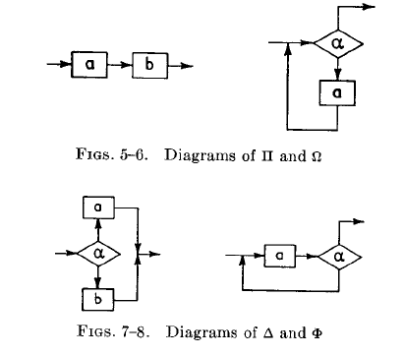
Figure 3-1. A portion of Bohm and Jacopini’s original manuscript as it appeared in the Communications of the ACM, volume 9, number 5, May 1966.
Bohm and Jacopini used a simple system of building flow diagrams with two symbols: rectangles to show each step in an algorithm, and diamond shaped boxes to show what they called a “logical predicative”. More commonly, the diamond symbol for a logical predicative is called a “decision diamond”, a “decision box” or a “conditional”.
To say that one thing is “predicated” on another means that one thing is determined by another. In other words, there is some condition that will determine what happens next. In an algorithm, these conditions will be either true or false. If the condition is true, one thing happens, if the condition is false, then something else happens. The path through an algorithm each time it is executed is determined by the state of the true or false conditions in that algorithm at that time. This is what flow diagrams are designed to show.
NOTE: Bohm and Jacopini’s notion of flow diagrams was relatively simple. It should not be confused with a more complex “tool” for algorithm design know as a flowchart. Flowcharts were actually more complicated tools because they allowed the use of lots of different shapes. Figure 3-2 shows a flowcharting template first introduced by IBM in 1969. It was accompanied by a 40-page manual showing the proper way to use all of the symbols. Phooey!!
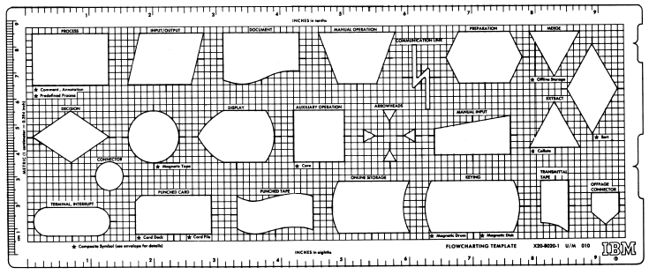
Figure 3-2. The IBM flowcharting template introduced in 1969.

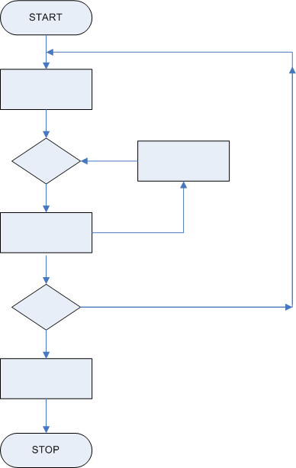
Figure 3-3. A flowchart drawn using only
three simple symbols.
In the rest of this chapter we will use a simple version of a flow diagram to help describe the elements of logical structure found in algorithms. We will only use three symbols: rectangles and diamonds as Bohm and Jacopini did, along with an oval shaped box to mark the beginning and end of an algorithm, as shown in Figure 3-3. The oval shape is called a terminator (no relation to “Ahnold”). There should be only one terminator at the beginning of an algorithm and one terminator at the end of an algorithm, since each algorithm should have one beginning, called an entry point, and on end called an exit point. Usually they are labeled with the words “start” and “stop”

Linear Sequences
The simplest element of logical structure in an algorithm is a linear sequence, in which one instruction follows another as if in a straight line. The most notable characteristic of a linear sequence is that it has no branching or looping controls – there is only one path of logic through the sequence, which doesn’t divide into separate paths, and nothing is repeated.
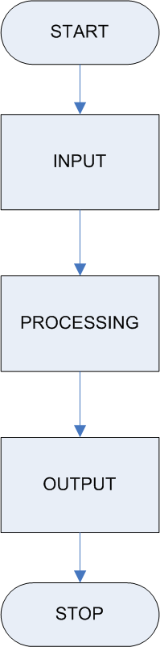
Figure 3-4.
A linear sequence
On a flow diagram this would appear as a single path of logic, which would always be executed one step after another, as shown in Figure 3-4.
Linear sequences are deceptively simple. It doesn’t seem very complicated to do one thing, then another, and then another, but it can be. Programmers need to make sure that linear sequences meet the following criteria:
- They should have a clear starting and ending point.
- Entry and exit conditions need to be clearly stated. What conditions need to exist before the sequence starts? What can we expect the situation to be when the sequence is finished?
- The sequence of instructions needs to be complete. Programmers need to be sure not to leave out any necessary steps. (This is harder than it sounds.) The sequence of instructions needs to be in the correct order.
- Each instruction in the sequence needs to be correct. If one step in an algorithm is wrong, then the whole algorithm can be wrong.

Branching Routines
Sometimes an algorithm reaches a point where things can go one way or another. Consider this example of a student who has chemistry lab at 2:00 pm on Fridays only.
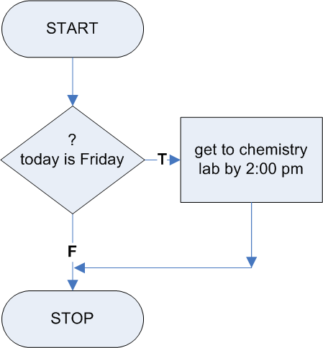
Figure 3-5. A selection sequence.
IF (today is Friday)
THEN (get to chemistry lab by 2:00 pm).

Diagrammed as part of flow diagram, this logic control structure would appear as shown in Figure 3-5.
This is an example of a branching control or branching routine. A branching routine occurs whenever the path or flow of sequential logic in an algorithm splits into two or more paths. Each path can be called a branch. Branching routines are also known as selection sequences or selection structures. The expression “today is Friday” is a special logic control feature called a condition. We will have more to say about conditions later in this chapter, but for now all you need to know is that every IF … THEN logical structure is controlled by a condition. That is, the resulting execution sequence depends upon the value of the condition. A condition may have only one of two values – true, or false. In the above example, if the condition “today is Friday” is true, then we know we have to “get to chemistry lab by 2:00 pm.” If the condition is false, we simply skip this step.
If there are two possible paths then the routine is known as binary branching. If there are more than two paths, then it is called multiple branching. It is possible to rewrite each multiple branching routine as a collection of binary branching routines. Consider the buttons on an elevator in a high-rise building. When you enter the elevator and press a button for the floor you want, it would seem that you have been faced with the equivalent of multiple branching. You are selecting one floor from many. However, you could also think of this as many binary branching routines – as a collection of questions like: “Do you want floor 2 or not”? “If not floor 2, Do you want floor 3 or not?”, and so on. The exercises in Alice later in this chapter only look at binary branching, not multiple branching. In fact, Alice does not have an instruction for multiple branching.
You should also know that there are two kinds of binary branching. One is called a binary bypass, and one is called a binary choice. In a binary bypass, an instruction is either executed or bypassed, as shown in Figure 3-5 above. In a binary choice, one of two instructions is chosen, as shown in Figure 3-6. As shown in this figure, if the condition “Today is Monday or today is Wednesday or today is Friday” is true, then the algorithm step “go to Math Class” is carried out. If, on the other hand, this condition has the value false, then the step “go to History class” is carried out. The difference between a bypass and a choice is subtle but significant. In a binary bypass, it is possible that nothing happens, whereas in a binary choice, one of the two instructions will occur, but not both.
A Brief Digression – Pseudo Code
The flow diagram is a tool that allows us to represent the logical control of algorithms using a two-dimensional picture. This is often very help for beginning programmers or the more visually oriented. Sometimes, however, computer programmers use a more formal language, usually called structured language or pseudo-code or, to describe algorithms. The term pseudo-code comes from the fact that it looks something like the code in a computer programming language, but not quite. It’s like code, but not really code, only a tool to help describe and understand algorithms, just as flowcharts do.

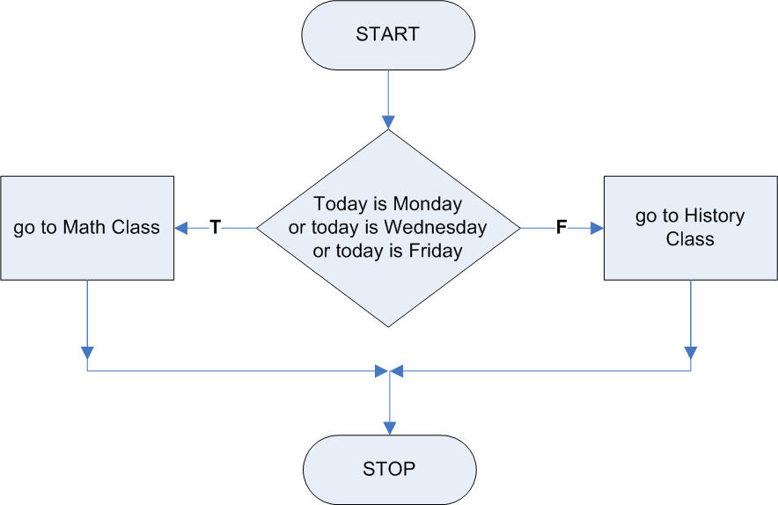
Figure 3-6. A binary choice
In pseudo-code, a bypass is equivalent to an IF (condition) THEN (instruction) command. If the condition is true, then the instruction is executed; if the instruction is not true, then the instruction is ignored, and nothing happens. The chemistry lab example above shows a binary bypass.
A binary choice is equivalent to an IF (condition) THEN (instruction A) ELSE (instruction B). If the condition is true, then instruction A is executed; if the condition is not true, then instruction B is executed. Either instruction A or instruction B, will be executed, but not both. One of the two always happens.
Consider again the example illustrated in Figure 3.6. As shown here, we have a student who has Math class on Monday, Wednesday, and Friday, and History class on Tuesday and Thursday. The pseudo-code algorithm for the student’s day might look something like this this:
IF (today is Monday, or today is Wednesday, or today is Friday)
THEN (go to math class)
ELSE (go to history class).

We now consider an example in which we illustrate the idea of a block of instructions. A block of instructions is a sequence of instructions in an algorithm which logically go together. Such a sequence could take the place of a single instruction anywhere in an algorithm, including in binary branching routines. The following pseudo-code for an algorithm to add two fractions illustrates this idea. (The equivalent flow diagram is illustrated in Figure 3-7.)
BEGIN
Get fraction A
Get fraction B
IF (fraction A and Fraction B have different denominators) THEN
{
find the lowest common denominator
convert fraction A to an equivalen fraction with that denominator
convert fraction B to an equivalent fraction with that denominator
}
add the numerators of the two fractions to find the numerator of their sum
print the result
END
In this example, the condition is in parenthesis and the beginning and end of the block of code are marked with brackets { … }. You could use the words BEGIN and END to mark any block of code, but brackets are fairly common in computer languages like C++ and Java, so they are often used as shorthand for BEGIN and END in pseudo-code. Also notice the block of code is indented, which makes it easier for people to read the pseudo-code.
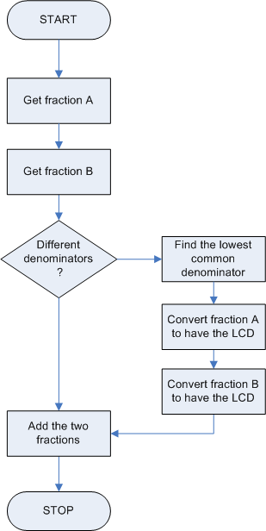
Figure 3-7. Algorithm to add two fractions
Note again, that one thing is common to all binary branching routines, and , as we shall see, to all repetition sequences as well – there must be a condition to determine what to do. These conditions will be either true or false when the algorithm is executed. They are a form of conditional logic know as Boolean logic, which will be discussed below following the section on repetition sequences.

Loops
In the branching routines above, the algorithms split into different paths that all moved forward; nothing was repeated. Whenever we branch backward to a previous instruction, and then repeat part of an algorithm, then we have what is known as a repetition sequence. A repetition sequence forms a loop in an algorithm such as in the following example for printing the numbers from 1 to 10. Let’s look at both the pseudo-code and a flow diagram for the algorithm.
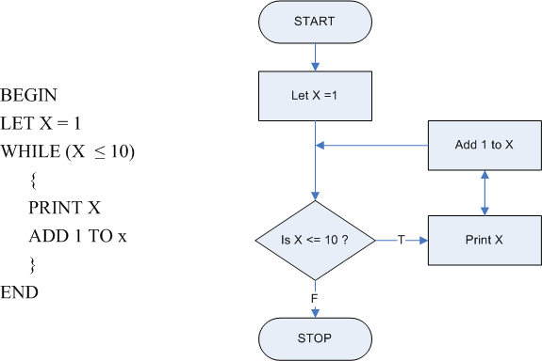
Figure 3-8. An algorithm with a loop for printing the integers from 1 to 10.

In this algorithm, the word “WHILE” is used instead of the word “IF”, as in branching. In pseudo-code, as in many programming languages, this tells the computer to come back to the conditional expression when the block of code following the WHILE instruction is finished. Each time the condition is true, the computer will execute the block of code, and then come back to the condition again. When the condition is no longer true, the block of code will be ignored, much like a binary bypass, and the computer will move on to whatever comes next in the algorithm. You can see that the repeated block of code forms a loop in the algorithm.
Just as there are different kinds of branching routines, there are different kinds loops. The example above is known as a counter-controlled loop. Like all loops, this loop has a control variable in its condition. A variable is like a placeholder or a variable from algebra that stands for a value that could change. In this counter-controlled loop, the variable X stands for a number, sometimes called a counter, used to keep track of how many times to go through the loop. In this case, X is initialized to 1; the WHILE instruction tests to see if X is at 10 yet; and X is incremented by 1 each time the loop is executed. The loop is executed while the control variable X is less than or equal to 10. When it gets to 10, then the loop stops.
The loop in Figure 3-8 is also a pre-test loop, meaning that the test to determine whether or not to go though the loop comes before the block of code to be executed. Traditionally, there are four parts to every pre-test loop:
Initialization – set the first value of the control variable
Test – look at the control variable to see if the loop should be executed
Processing – instructions defining the process to be repeated
Update – change the value of the control variable
Let’s look at our example again, this time using COUNTER instead of X and highlighting the four parts of the loop.
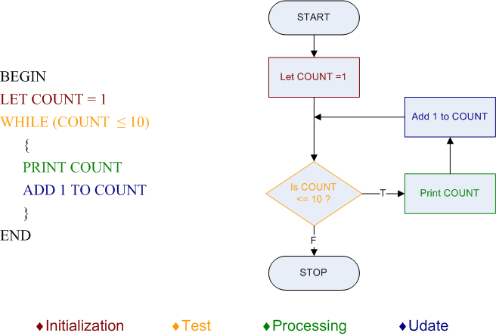
Figure 3-9. The four parts of a pre-test loop shown with color-coding.

The loops we have seen so far are all pre-test loops. In a pre-test loop, the test to determine whether or not to continue executing the loop comes before any other instructions that are to be repeated. It is also possible to set up a post-test loop, with the test to determine whether or not to repeat a loop coming at the end of the loop. Figure 3-1 shows diagrams of four different logical structures form Bohm and Jacopini’s original manuscript. Look closely at both the top-right diagram and the bottom-right diagram. In both cases, the condition in the diamond shaped box is labeled with the Greek letter “α” (alpha) and the rectangular box representing an instruction to be repeated is labeled with the letter “a”. Notice that the top structure is a pre-test loop with the decision diamond before the instruction to be repeated, and the bottom structure is a post-test-loop, with the decision diamond after the instruction to be repeated.
Some computer programming languages contain a REPEAT (instruction) UNTIL (condition) structure to set up a post-test loop. However, many computer scientists suggest that only pre-test loops should be used in programming, for reasons that are beyond the scope of this book. However, to illustrate the point, consider the following two programs:
- When the computer is turned on, the program launches a nuclear weapon and then asks “Should I do that again?”
- When the computer is turned on, The program asks “Do want me to launch a nuclear weapon”. If the answer is yes, it launches a weapon and then it asks if you want to repeat the process.
The second program is slightly more complicated than the first, but which do you think is a safer program to run?
Unfortunately, people often think very differently than the way a computer works. We tend to do something first, then ask if it should be repeated, like a post-test loop instead of a pre-test-loop – just the opposite of what computer scientists suggest. Alice has a WHILE command for pre-test loops, but it does not contain any commands to set up a post-test loop.
In addition to being a pre-test loop, the example in Figure 3-9 above is also a counter-controlled loop. Every loop in a computer program is also either a counter-controlled loop, described in the next paragraph, or a sentinel loop, described below. In a counter-controlled loop, the control variable is a called a counter. We need to know the initial value, the final value, and the increment for the counter. The counter starts with the initial value, then increases by the increment each time, until it reaches the final value. In Figure 3-9, the initial value is 1, the increment is 1, and the final value is 10.
It’s important to make sure that the initial values, the final value, and the increment all match each other. If a computer were programmed to start the counter at 100, and then increase it by 1 each time through the loop until reached 0, we would probably get some unexpected results.
Alice handles counter-controlled loops for us with a special LOOP instruction. So, even though you should know about counters and increments, they will be handled for us automatically in Alice. However, Alice’s loop command codes do not let us use a negative increment. If you wanted to start at 100 and count backwards until you reaches zero, such as the countdown for launching the space shuttle, then you would need to set up your own count controlled loop using the WHILE command.
Not every loop is a counter-controlled loop. Some loops check for a particular value or condition that does not involve a counter to determine when to stop running. We call such loops (those not easily or naturally controlled by a counter) conditional loops. We also have a special case of conditional loops, called a sentinel loop, which most often involve reading data from a file. We use a sentinel loop control to instruct the computer to keep reading in data until it reaches a particular value or until it reaches a special value called an “end of file marker”. This latter approach is illustrated next.
BEGIN
OPEN a data file
READ in a piece of data from the file
WHILE (the data is not an “end-of-file” marker)
{
COPY the data to a new location
READ in the next piece of data from the file
}
CLOSE the file
END
This loop is called a sentinel-controlled loop because it continues to repeat as long as (while) we have not encountered the special sentinel value (end-of-file in this case) in our data file. The structure of the loop requires repeated checks for the sentinel value (the condition embedded in the WHILE statement -- data not an “end-of-file” marker).
As another example, imagine a machine that tests a car door. To control this machine, we could program a computer using a conditional (WHILE) loop. The machine would open the door, and then close and it would be programmed to repeat this process as long as (WHILE) the door remains attached to the car. This is illustrated in the following pseudo-code.
BEGIN
LET counter = 1
WHILE (door is still on the car)
{
open the door
close the door
increment counter by 1
}
PRINT “The door fell off after opening and closing it this many times:”
PRINT counter
END

This loop has a counter, but the counter does not control when the loop stops running. We therefore refer to this kind of loop as a WHILE or conditional loop because it continues executing as long as the condition “door is still on the car” remains true. Remember that conditions can have the value true or the value false, and that is all. We not only use these specially valued logic features to control IF … THEN logic structures, but we also use them to control WHILE loops.
Our final example is a bit more complicated. Suppose we are asked to write code sequence to compute and print the decimal value of the fraction ½ raised to the nth power (½)^{n}, for values of n starting at 0 and continuing in steps of 1 as long as (½)^{n} is larger than zero. In other words, the values printed would start with 1.0 (the value of (½)⁰ ) and continuing with 0.5 (½)¹ , 0.25 (½)² and so on. Try writing this loop using the approaches outline above. We claim that writing this loop and the others just presented is not easy to do using a counter-controlled loop. Why not? For all you mathematicians out there – will this loop ever stop executing? In other words, will (½)^{n} ever compute the value of 0? Why or why not?
To summarize about loops -- when code in a computer program is repeated, the algorithm contains a repetition structure, which is also called a loop. Algorithms can contain counter-controlled loops or conditional loops (not count-controlled). Each loop is also a pre-test loop or a post-test loop. Alice has a WHILE instruction for pre-test loops, and does not allow post-test loops. Alice also has a special LOOP instruction for count-controlled loops.

Techniques to use in place of loops
Today, there are two methods of programming that are often more appropriate than loops in many situations -- event-driven programming and recursion. Event-driven programming is discussed later in this text. Recursion, a powerful programming tool in which a program calls itself, is beyond the scope of what we need to accomplish in the next couple of weeks.. Event-driven programming and recursion were not yet common practices when Bohm and Jacopini did their work in the 1960’s. In fact, the two most popular early programming languages, Fortran and COBOL, did not even allow recursion or contain features for event-driven programming when they first appeared.
It is common to see older programmers (like your instructor), as well as many people who were trained by older programmers, using loops in places where event-driven programming or recursion would be more appropriate. The use of events and recursion is often a little harder than the use than loops, and they have more overhead, meaning that the final, translated program, uses more memory. In the long run, when event handling and recursion are used appropriately they can actually save resources and work better than loops.
We will not discuss recursion or event handling any further in CIS C071, so you may skip the immediately following material, as marked below.
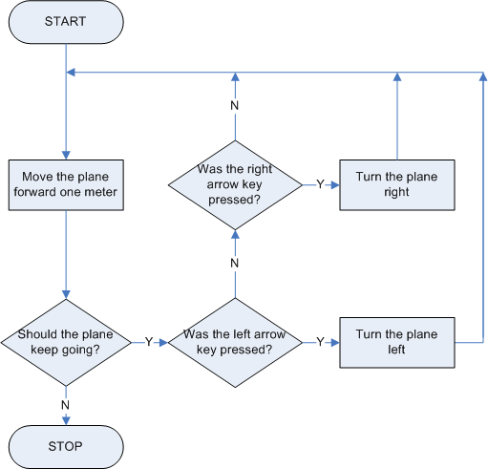
Figure 3-10. An algorithm with a loop controlling an airplane. This can also be accomplished with event-driven programming.

*** Skip to next marker ***
Sometime a person’s knowledge of programming and related mathematics needs to be more sophisticated to tell when an event or recursion should be used in place of a loop, but you already know enough about events in Alice to ask yourself if it might be more appropriate to prepare an event to handle the situation whenever you are considering the use of a loop. The seaplane world from Exercise 3.3, which starts on page xx, contains events to check the arrow keys to see if the user is trying to turn the seaplane. Instead of using an event, older programmers would tend to put the code to make the plane fly in one large loop that would repeatedly check to see if the arrow keys had been pressed such as in Figure 3-10 below. Clearly, events are a better way to handle this.
Even though the use of recursion and events are often better solutions in many cases, we still see them used less than they probably should be.

Boolean Logic
As we mentioned earlier, WHILE loops and IF … THEN branching routines both contain conditions that are either true or false. In 1854, George Boole, the first Professor of Mathematics at Queen’s College in Cork, Ireland, published a book titled “An investigation into the Laws of Thought, on which are founded the Mathematical Theories of Logic and Probabilities”. Boole outlined a system of logic and a corresponding algebraic language dealing with true and false values. Today that type of logic is called Boolean logic, and his language is called Boolean algebra. The conditions that exist in loops and branching routines are a form of Boolean logic.
A full discussion of Boolean algebra is beyond the scope of this book, but we will take a moment to look at some of the basic principles of Boolean logic.
Boolean logic is a kind of mathematics in which the only values used are true and false. There are three basic operation in Boolean logic – AND, OR, and NOT. The tables in the figures below show the rules for these three operations.
A AND B
  A
   |  | T | F
  B | T | T | F
  B | F | F | F
  A OR B |  | A
   |  | T | F
  B | T | T | T
  B | F | T | F
  NOT A | A
  NOT A | T | F
  NOT A | F | T
Figure 3-11. Truth tables for the primary Boolean operators AND, OR, and NOT.
The AND and OR operations are binary operations, meaning that they need two operands. Basically, when two true values are combined in the AND operation, the result is only true if both values are true. Otherwise, the result is false. In the OR operation, if either value is TRUE then the result is true.
The NOT operation is a unary operation, which means that it works on only one operand. It simply reverses the true or false value of its operand – NOT true yields false and NOT false yields true.
This seems like common sense. Statements like (today is Monday AND this is March) can be evaluated for their true or false value. But consider the following dialog:
BOSS: Give me a list of all the customers who live in Pennsylvania and New Jersey.
PROGAMMER: Let me get this straight – you want a list of all the customers who live in either Pennsylvania or in New Jersey. Right?”
BOSS: Yes, isn’t that what I just said?
The programmer, who has experience dealing with converting the informality of human language into a formalized computer programming language, knows what would happen if the condition (state = “PA” AND state = “NJ”) were used to create the list. If each employee lives in only one state, then both conditions could not possibly be true. What should the programmer do – give the boss a blank sheet of paper? Tell the boss the request is nonsense according to the rules of Boolean logic? The programmer’s response clarified the boss’s request, and no one was out of a job.
Boolean expressions can become long and complex with many nested AND, OR, and NOT clauses layered together. Professional programmers often use Boolean algebra and other tools, when dealing with the layered complexities of Boolean logic.

Comparing Values
Consider the following warning in a modern automobile:
The passenger-side air bag may cause injury to children who are under the age of 12 or who weigh less than 48 pounds. They should not sit in the front passenger seat of this car.
The condition in this warning might be expressed in pseudo-code like this:
IF (age < 12 OR weight < 48)
THEN do not sit in the from passenger seat
In this example, two items, each with a true or false value are joined by the OR operation. The two items each involve comparisons of values. This is most often the case with Boolean conditions: they are based on expressions that compare values. The symbol “<” in the above example stands for “less than”. There are six such comparison operators used in computer programming, as shown below.
Condition | In Math and Algebra | In Computer Programming
A equals B | A = B | A == B
A does not equal B | A ≠ B | A <> B or A != B
A is less than B | A < B | A < B
A is greater than B | A > B | A > B
A is less or equal to B | A ≤ B | A <= B
A is greater or equal to B | A ≥ B | A >= B
Figure 3-12. The six conditional comparison operators used in computer programming

Notice that several of the computer programming symbols such as “<>” are composed of two characters. This is because modern computer keyboards do not include a single symbol for these comparison operators, such as the symbol “≠” that is often used in standard algebra.
It’s clear that comparisons of numeric values can be performed, but what about other data types, such as character strings? Most programming languages today allow the comparison of almost every different data type usable in the language. Thus, all sorts of numeric values, character strings, and even objects such as instances of animals, makes of cars, and university students can be compared. In attempting such comparisons, however, we should be careful that the operands used should be of the same type. In other words, we should compare only integers to integers, strings to strings, and makes of cars to makes of cars. It is not a good idea (and in fact is illegal in most languages) to attempt to compare integers and strings or even integers and other types of numeric values.

Concurrency
It is possible for one computer, or several computers working together, to work on several parts of an algorithm at the same time. Each path of logic that is being executed is called a thread of sequential logic, and algorithms that run multiple threads at the same time are called parallel algorithms. The process of running multiple threads is called concurrent execution, or concurrency. Sometimes computers concurrently execute different parts of the same program, and some time they concurrently execute parts of different programs.
Parallel algorithms can be quite powerful, but they can be difficult to design and use. Many problems arise, such as the different threads interfering with each other. It might be easier to run a restaurant kitchen with four chefs instead of one, but if things aren’t carefully coordinated than chaos could ensue.
A simple version of concurrency is available in Alice. There is a Do together logical structure that can be used in any method, and a “For all together” tile that can be used with lists, which are later in the text. We will not say much about these logical structures. You should know that they exist and you should understand how they behave. What goes on behind the scenes is beyond the scope of this text.

Exercise 3.1 – Branching in Alice Methods
In this exercise you will modify the generic triple jump world from chapter 2 to include branching in the main method. The world contains three objects, each one a character from Alice in Wonderland. The existing version of the world contains a method to make all three characters jump, one at a time. The algorithm in world. my first method is simply a linear sequence. You will modify it to include user input and If…Then commands. The new program will ask the user questions about which character should jump, then have one of the three characters jump, depending on the answers to those questions.
~~~ Steps to Perform ~~~
Step 1. Start the Alice software and open the “generic triple jump” world created in Chapter 2. If you cannot find the world, then either load the world from the CD that comes with this book, or go back to Chapter 2 and follow the directions for Exercises 2.2 and 2.3 to create and save the world before continuing.
Step 2. Look at the code for “world. my first method”. You can see that there are six instructions that from a linear sequence in the program, as shown in Figure 3-13. Delete the first instruction, in which Alice says “Simon says Jump!”
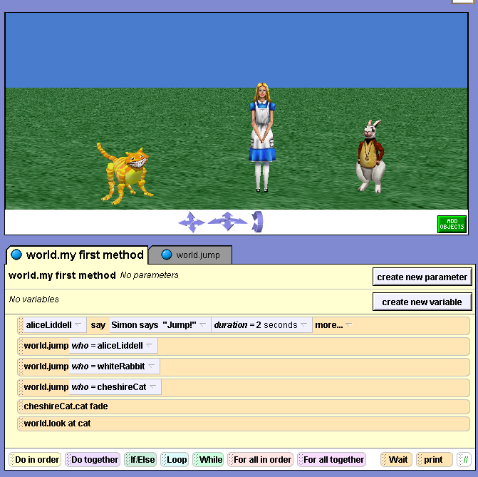
Figure 3-13. The generic triple jump world’s “world.my first method”
Step 3. Alice has a world-level function to ask the user a yes or no question. You are going to add two questions to world.my first method. First, the method will ask if the user wants Alice to jump. If the answer is yes, then Alice will jump. If the answer is no, then the method will ask if the user wants the White Rabbit to jump. If that answer is yes, then the White Rabbit will jump, if the answer is no, then the Chesire Cat will jump. The last two instructions in the method will follow that, as in the existing program. The pseudo-code and flowchart in Figure 3-14 below describe this algorithm:
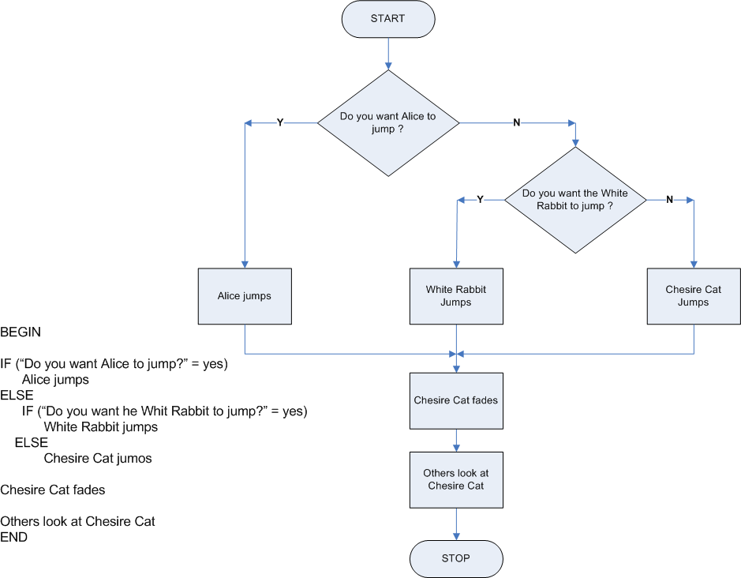
Figure 3-14. Psuedo-code and a flowchart specifying the program to be created in Exercise 3.1
You need to add an If...Then instruction to the method. The tile for this instruction is with the logic and control tiles at the bottom of the Editor area. Drag and drop a copy of the If…Then tile from the bottom of the editor area into the method in front of the three jump instructions. When you try to do this, a short menu will appear asking you if you want to use a true or false condition in the If command. Select true, and a light blue [If..Then] tile will appear in your method.
Step 4. Next you need to put the function to ask the user a yes or no question into the method. This question will return a value of true if the user answers “yes” to the question and false if the user answers “no”. This function may be used any place where true or false can be used. In this case, it will replace true as the condition for the If..Then command. Select the world tile in the Object tree, and then the Functions tab in the Details area. Scroll through the list of functions and find the function titled “ask user for yes or no”. Drag and drop a copy of this function into the If..Then tile in place of true following the word “If.”
Step 5. A short menu will appear with the options “Yes or No?” and “other ...”. This menu is asking you how you want to word the question that the user will see – do you want it to be “Yes or No?” or something else. Choose “other ...”, and the Enter a string dialog box will appear. The character string entered here will form the text of the question the user will see. Type “Do you want Alice to jump?” as the string and click the okay button. The question function will now appear in the If...Then tile in place of true as the condition for the IF command. Figure 3-15 shows the place in the function tab of the World’s Details window where you can find the question tile, and the method with the questions in place in the nested if then command you are trying to create.
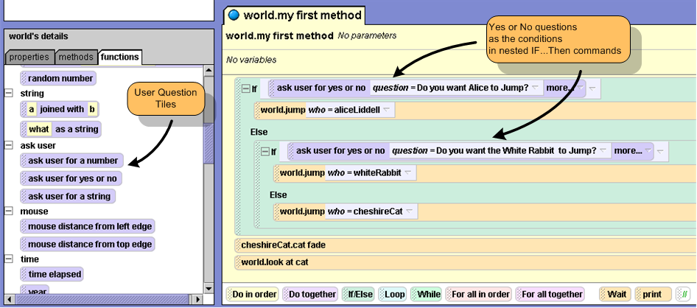
Figure 3-15. User questions in nested IF commands. Notice how the code in world.my first method matches the specification in Figure 3-14 above.

The method you started with had three jump instructions in a row. Drag tiles into the method as necessary and rearrange them to form the nest IF … THEN commands with the three jump instructions in them as shown in Figure 3-15.
Your method should now match the specifications as shown in the flowchart and pseudo-code shown above. You are now ready to test the new program, but first you should save your work. Save the world with the name “jump user choice”.
Step 6. It’s now time to test the world. It’s a good idea to test the world under all possible circumstances, which in this case means trying the world with all possible combinations of user input. This calls for a testing plan.
The specifications show that there are three possible paths for the logic in the program. The answer to the first question could be yes or no. If it’s yes, then the Alice should jump and the program is done. If it’s no them we go to the second question. If the answer to the second question is yes then the White Rabbit jumps, and the program ends. If the answer to the second question is no, then the Chesire Cat jumps, and the program ends. The testing plan must include three trials, one for each possibility, as follows:
Trial 1 – first answer “yes”
expected outcome – Alice jumps
Trial 2 – first answer “no”, second answer “yes”
expected outcome – White Rabbit jumps
Trial 3 – first answer “no”, second answer “no”
expected outcome – Chesire Cat jumps
Now test your program according to the testing plan and see if it works as expected. If it does, we’re done, if not then it’s time to debug, etc. Remember to save your world again if you make any significant changes.

Exercise 4.2 – Branching with Random Numbers
In this exercise you will modify the world form Exercise 3.1 to have the computer randomly select who will jump instead of asking for user input. The use of random numbers (and random number generators) is an important part of programming since they enable us to simulate many real world processes, especially those in which results are dependent on what often appear to be or are in fact, random sequences of events. If you are not quite sure what all this means, consider for a moment what happens when you play a board game such as Monopoly or Clue. Or consider what happens every time you pick a new letter in the game of Scrabble. If we wanted to simulate these activities on the computer (and we know this has already been done very effectively) we would make considerable use of random number generators and random numbers.
Fortunately for us, Alice has a world level function so we do not have to write our own. Alice’s random number generator function returns a random number in a specified range. The values that it returns are six digit numbers that fall within a range of values that we can specify. In this exercise, for example, we will ask Alice to return a number between 0 and 3 (including 0 but excluding 3). Alice will return numbers such as 1.83475, 0.41257, 2.89175, and so on. All of the values it returns will be between greater than or equal to 0, but less than three.
We will write our code so that if the random value is less than 1, then Alice will jump, if it is greater than or equal to 1 but less than 2, then the White Rabbit will jump. If it greater that or equal to 2 but less than 3, then the Chesire Cat will jump. Figure 3-16 shows the expected results of our program. The logic is very similar to the user input program in Exercise 3.2, with nested if commands to determine which character will jump.
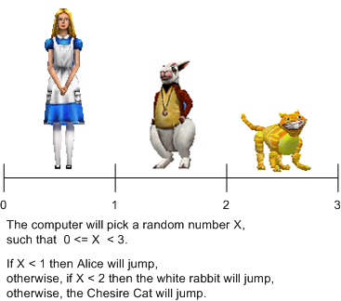
Figure 3-16. The value of the random number will determine who jumps.

~~~ Steps to Perform ~~~
Step 1. Open the “jump user choice” world from the previous exercise.
Step 2. You need to add a variable to our program to store the random number. Figure 3-17 shows what the code for the method will look like after you do this. You can refer to this diagram to guide through the next several steps. Click the button on right side of “world.my first method” to add a new variable to the method. When the dialog box appears, name the variable “determinant”, since it will determine who jumps, and make sure that “number” is selected as the type, then click okay. You will now see a variable tile for determinant appear at the top of the method.
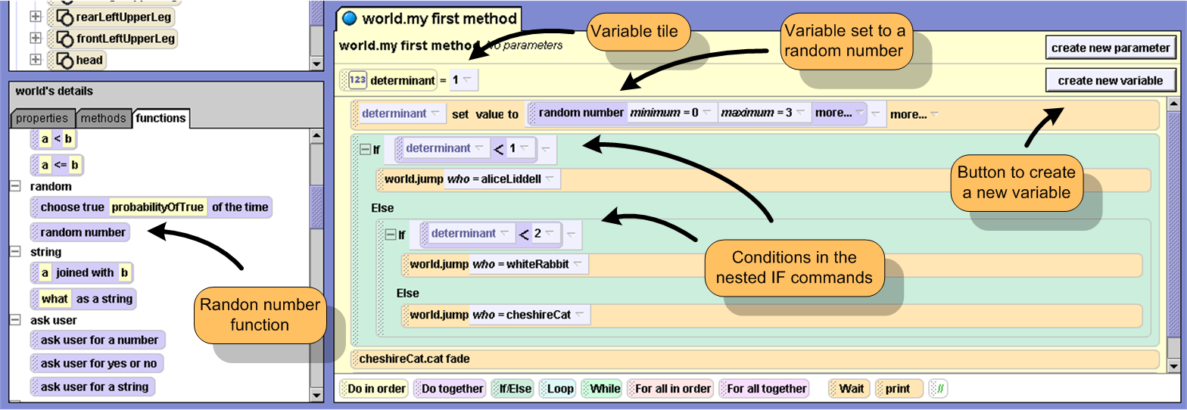
Figure 3-17. “world.my first method” with random numbers instead of user input

Step 3. Next you need to tell the computer to set the value of “determinant” to a random number. Drag the variable tile down into “world. my first method” as a new first instruction before the “if” commands. When you do this, a “set value dialog box will appear. Tell the computer that you want to set the value of “determinant” to 1. The 1 is only a place holder; we will change it to random number next.
Step 4. Now you need to tell the computer to set the value of the variable “determinant” to a random number instead of a 1. You need to put a copy of the random number function tile into the set value tile in place of the number 1. Select the world tile in the Object tree, and then the Functions tab in the Details area. Scroll through the list of functions and find the function titled “random number”. This is actually the Alice random number generator function that we will need to use.
Drag and drop a copy of this function into the set value tile in place of the number 1. The set value tile should now look like this:.
Step 5. You need to tell the computer what range of values to use when picking a random number. Click on the word “more” in the blue random number tile, and set the minimum value to 0. Click on the word more again, and this time set the maximum value to 3. Now the “set value” tile in your method should look like it does in Figure 3-17.
Step 6. The nested if commands still contain conditions based on the user question. You need to replace these conditions following the word IF in each of the nested if commands with conditions based on the random number. Drag the “determinant” variable tile from the top of the method down into the first IF command in place of the blue “ask user yes or no” condition tile. When you do this a short menu will appear select “determinant <” and 1 as the value. Now the first IF command tile should look like it does in Figure 3-17, above.
Do the same thing for the second IF command, but this time, choose 2 as the value, so the second if command should be “if determinant < 2”, as in Figure 3-17.
Step 7. That’s it! The program should now be ready to select a random number and then make one of the three characters jump based on the value of the random number. You need to save and test the world. Save the world with name “triple jump random”.
We need a testing plan for our program. If things work correctly, then one of the three characters should jump each time the world is run. Which character jumps depends on the value of the random number that the computer picks for the variable you named “determinant”.
To test the program properly, you would need to run it several hundred or several thousand times, and keep track of how many times each character jumps. Over a long period of time, we would expect each character to jump about one thirds of the time the program runs.
This will be left as an exercise at the end of the chapter. For now, test the program to make sure that the same character does not jump all the time, and that each of the three characters jumps at least part of the time. Play the world, and then use the restart button several times to replay the world. Since the numbers are random and not part of a pattern, the same character may jump several times in a row, but over a larger number of trial runs, each of the characters should jump at least once.

Exercise 4.3 – Creating a Simple Counter-Controlled Loop
In this exercise you will experiment with counter-controlled loops in Alice.
Every counter-controlled loop has a control variable called a counter or an index. The index must have an initial value, a final value, and an increment. The loop starts with the index at the initial value, adds the increment to the index each time through the loop, and ends when the final value is reached. If the increment is positive, then the index increases by the increment each time through the loop; If the increment is negative, then the index decreases by the increment each time through the loop. Alice has a special “Loop” command to make it easier to set up a counter-controlled loop, but the command does not let you use a negative increment.
The “loop” instruction has two different versions: a simple version and a complicated version. Both versions of the same loop are shown below in Figure 3-18.
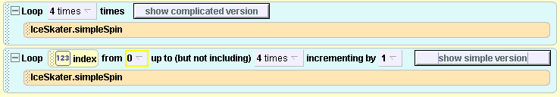
Figure 3-18. Simple version and a complicated versions of the same loop
In the simple version, the programmer simply tells Alice how many times to repeat the loop. The loop will start the index at 0, increase the index by 1 each time, and stop when the loop has been executed the specified number of times. In the complicated version, the programmer has access to the initial value, final value, and increment.
In next several steps, you will create a simple Alice world with our three jumping characters to, illustrate both the simple and complicated versions of Alice’s loop command. First we will create a simple program to make the characters jump a specified number of times, then we will have the height that one of the characters jumps depend on the value of the loop index.

~~~ Steps to Perform ~~~
Step 1. You will modify the “generic triple jump” world created in Chapter 2 and used again in the beginning of Exercise 3.1. Open the world, or create it again ad described in Exercises 2.2 and 2.3 in Chapter 2. A copy of the finished world is on the CD accompanying this book.
Step 2. In this program, all three characters will jump at the same time. Drag a “Do together” tile from the bottom of the editor area and place it in your method after the three jump instructions, but above the “chesireCat.cat fade” tile. Now drag each of the jump instructions into the middle of the do together tile.
Step 3. We can test the world at this point to make sure that all three characters jump together. Save the world first with the name “triple jump loop” and then play the world. If all three characters jump at the same time, then move on to the next step. If not, then find and fix the error.
Step 4. Now we wish to add a simple counter-controlled loop to the program to make the three characters jump a certain number of times. Drag a “Loop” tile from the bottom of the editor area and drop a copy of it into the method just below the “Do together” tile and above the “chesireCat.cat fade” tile. When you do this, an “end” dialog box will appear asking you how many times you wish to repeat the loop. Select 5 as the number of times. Your program should now look like Figure 3-19.
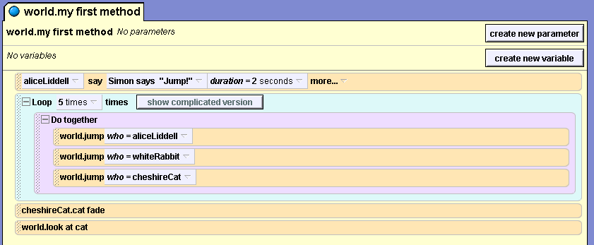
Figure 4-19. A simple count controlled loop
Step 6. We can test the world again, to make sure that all of the characters jump five times. Save the world once more, and then try it to see if it works. This demonstrates the use of the simple version of a loop command. If the program doesn’t work properly, review your work to find the error in your program, and then fix it. Once it works, you are finished with this exercise.

Exercise 3.4 More Complicated Count Controlled Loops
In this exercise you are going to work with the more complicated version of the “Loop” command, and use the Loop index to determine how high the Chesire Cat jumps. You will need to modify the generic jump method “world.jump (who)” to include a height parameter before so that we can do this.
Step 1. Open the “triple jump loop” world from Exercise 3.3, above. Select the “world” tile in the Object tree and the methods tab in the Details area. Save the world with the new name “triple jump loop 2” so that the changes you make will not alter the original “triple jump loop” world.
Step 2. You will now add a height parameter to the jump method. Click the edit button next to “jump (who) and the method world.jump) should open in the editor area. Click the “create parameter button” on the right side of the top of the method, as shown in Figure 3-17. A dialog box will appear asking you for the name and type of the new parameter. Use “height” for the name and select number as the type then click okay. Now the method has two parameters – “who”, which is an object parameter, and “height”, the number parameter that you just added.
Step 3. Next you will modify the “move up” and “move down” commands in the method to use the height parameter as the amount to jump instead of 1 meter. Drag the height parameter and drop a copy of it into the “move up” instruction tile in place of the value 1 meter. Do the same thing for the “move down” instruction. Now, instead of jumping one meter each time the generic jump method is used, the object will jump a specified distance.
Step 4. Now that a height parameter has been added to the jump method, you should be able to modify how high each character jumps in the program that calls the jump method. In this world, the method “world. my first method” calls the jump method for each of our three characters. Click on the edit button next to the “my first method” tile in the details area, and you will now see “world.my first method” in the editor area. Notice that a height parameter has been added to each jump instruction with the default value 1. You are going to replace the values for the height for the White Rabbit and then for the Chesire Cat.
The rabbit should be able to jump higher than Alice, so click on the height parameter in the “world.jump who= whitRabbit” tile in the middle of the method, and change the value to 2.
Save and test your world. The White Rabbit should be jumping twice as high as Alice and the Chesire Cat.
Step 5. Next you will make the Chesire Cat jump a different amount each time the loop repeats. To do this, first you need to be able to see the complicated version of the loop command. The loop tile contains a button to “show complicated version”. Click on this button now, and you will see the complicated version of the loop. You now have access to the initial value, final value and increment within the loop, as shown below in Figure 3-20.
Each time through the loop is called an iteration of the loop. The loop index starts at zero, and increases by one with each iteration, as follows: 0, 1, 2, 3, and 4. The loop starts counting at zero, and stops before reaching five. So, even though the loop executes five times, the first value of the index is 0 and the last value is 4.
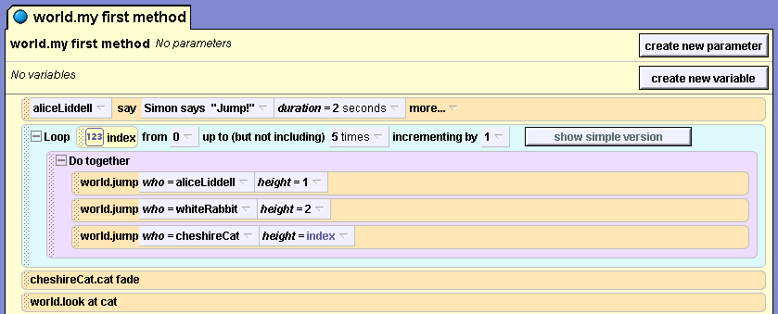
Figure 4-20. A complicated version of a count controlled loop.
You will now make the amount the Chesire Cat jumps equal to the value of the index. Drag the a copy of the index tile from the Loop instruction and drop it into the “world.jump who= chesireCat” tile in place of the value 1 as the height parameter. Your code should now look like Figure 3-20.
Step 6. Save the world and test it. The amount the Chesire Cat jumps should be equal to the index for the loop, which starts at 0 and increments by 1 each time, stopping before 5 is reached. The Chesire Cat should first jump 0 meters, then 1 meter, 2 meters, 3 meters, and 4 meters. He might be jumping off the screen the last few times.
The loop command in Alice is really intended to be used only in situations where the programmer wants to make something happen a certain number of times, such a s jumping five times. Remember, that a count contolled loop is just a special case of a sentinel loop. Whenever a more sophisticated loop is called for, such as one that counts backwards, it is best to create your own version of a count-controlled loop with the While command.

Exercise 4.5 Creating a WHILE Loop
In this exercise you are going to create a while loop to make our characters jump until a certain condition occurs. Remember that a sentinel is a value or condition that tells a loop when to stop executing.
You will use the “triple jump loop” world from Exercise 3.3 as your base world, modifying it to contain a WHILE loop instead of a counter-controlled loop. Figure 3-21 shows the algorithm for a simple count controlled “triple jump loop” program and the new algorithm for the “triple jump sentinel loop” world we wish to create.
BEGIN  Alice says “Simon says jump!”  Loop 5 times  {  Alice jump  White Rabbit Jump  Chesire Cat Jump  }  Chesire Cat fade  others look at Chesire Cat  END | BEGIN  distance = 1  Alice says “Simon says jump!”  While distance <= 5  {  Alice jump 1 meter  White Rabbit Jump 2 meters  Chesire Cat Jump distance meters  distance = distance +1  }  Chesire Cat fade  others look at Chesire Cat  END
Figure 3-21. A simple count controlled loop on the left, a sentinel loop on the right that functions like a count controlled loop.
~~~ Steps to Perform ~~~
Step 1. Open the “triple jump loop 2” world and make sure that “world.my first method” is visible in the editor area. First, you need to crate a new control variable for the WHILE loop that you will add to the program. Click on the “create new parameter” button, and a dialog box will appear asking you for the name and type of the new parameter. Use “distance” for the name and select number as the type, then click okay.
Step 2. You will now change the “world.jump who= chesireCat” instruction in the middle of the method to use “distance” instead of “index” as its height parameter. Drag a copy of the “distance” parameter tile the top of the method drop it into the “world.jump who= chesireCat” tile in place of the “index” as the height parameter.
Step 3. Next you will add a while loop to the program, move the “Do together” tile into this new loop, and delete the count controlled loop.
Drag a copy of the “While” tile from the bottom of the screen into the method just below the “Loop” tile and above the “chesireCat.cat fade” tile. A dialog box will appear asking you for the condition for the loop. For mow choose “true” as the condition, which we will replace in step 5.
Step 4. Now drag the “Do together” tile with its three instructions from the middle of the “Loop” tile and drop it into the middle of the “While” tile. We no longer need the “Loop” tile, so you should now delete it by dragging it to the trash can near the top of the Alice interface.
We now need to set up the code to make the while loop execute as desired. Remember from the reading at the beginning of this chapter that there are four parts to every pre-test loop, which is what we are creating: initialization, test, processing, and update. Each of these parts of the loop needs to be properly in place.
Step 4a. Loop Initialization
Distance is the control variable. In the variable tile at the beginning of the method, we can see that it is initialized to 1, so this will suffice as the initialization step for our loop.
Step 4b. Loop Test
The condition in the “While” command will be the test to see if the loop needs to be repeated. The algorithm in figure 4-x shows that the loop should continue while the “distance” value is less than 5. You need to modify the code in “world.my first method” to match this. Drag a copy of the “distance variable tile and drop it into the “While” tile in place of the value “true”. When the menu appears with different choices for the condtional expression, choose “distance <=” and set the value to 5. Now the loop will repeat while of distance is greater than or equal to 5. Once the test in the While loop shows that the values has reached 5, then the loop will stop repeating.
Step 4c. Loop Processing
The “processing” part of a loop includes the instruction to be repeated in the body of the loop. In this case, the three jump instructions make up the processing part of the loop.
Step 4d. Loop Update
The control variable, in this case “distance”, needs to be changed each time the loop is processed, or else the loop would never end. The update part of the loop is usually the very last instruction in the loop, so that the control variable is updated just before the loop restarts. You need to put an instruction at the end of the loop to change the value of “distance”. Drag the “distance” variable tile from the top of the method and drop a copy at the bottom of the loop. When you do this, a short menu will appear allowing you to choose how you wish to change the value of “distance”. You could choose increment or decrement to increase or decrease the loop by 1 with each iteration of the loop, but in this case, you should select “set value” and them select “distance” as the amount so that we can build a math expression to change the value.
The set value tile now says “(distance) set value to (distance), which doesn’t change anything, but you’re not finished yet. Click on the second word “distance”, which is between the phrase “set value to” and in front of “more”, and select “math” from the menu that appears. Then select “distance +” and set the value to 1. The tile at the end of the loop should now look like this: .
Step 5. Now “world.my first method” should match the specifications as shown in Figure 3-21. You need to save and test the world. Distance will start at 1, and increment by 1 each time through the loop up to and including 5. The three characters should jump together – Alice should always jump 1 meter, the White Rabbit should always jump 2 meters, and the Cheshire cat should jump “distance meters”. Distance will be 1, then 2, 3,4, and finally 5. Save the program and test it to see if it works as expected. That is the end of this exercise, but this world is used in several of the optional exercises at the end of this chapter, in which you can experiment with sentinel loops.

What to Do Next?
After finishing this exercise you may want to:
- Look at the objectives at the beginning of this lesson. Can you do all of the things listed? Can you define all of the terms listed?
- Alice contains a world level function that will ask the user for a number. Create an Alice world with a character of your choice that will ask the user for a number, cause the character to jump up, use a loop to spin around the number of times specified, and then come back down. What is the difference between using the “turn” and “roll” methods to make the character spin one revolution each time through the loop?
- Modify the “triple jump loop2” method so that Alice jumps if the index is equal to 1, the White Rabbit jumps if the index is equal to 2, the Chesire Cat jumps if the index is equal to 3, and all three characters jump if the index is equal to 4.
- Modify the While loop in “triple jump WHILE loop” to do each of the things listed below. Each is a separate modification of the original loop; it is not intended that one program should do all of these things.
  - Make the distance the Cheshire cat jumps increase by .5 meters each time through the loop.
  - Make the sentinel to be Alice’s height, rather than the number 5, so that the loop will execute when the distance is less than or equal to Alice’s height, but stop when the distance passes her height. To do this you can use the character level function that returns Alice’s height.
  - Make the distance start at a higher number and decrease each time until it is less than or equal to a smaller value. For example, the initial value could be 5, the increment could be -1, and the final value could be 1.
  - Make the distance the White Rabbit jumps increase each time through the loop, while the distance the Chesire Cat jumps decreases at the same time. Consider the following: what happens to (5 – distance) as distance increases from 1 to 5?
- The animals object gallery contains a pterodactyl. The disk that comes with this book contains a world named “flapping pterodactyl” with a character level method named “flap” that will cause the pterodactyl to flap its wings. Do each of the following:
  - Create a method called “pterodactyl fly” that will make the pterodactyl move forward while flapping its wings, then create a loop in “world.my first method” to make the pterodactyl fly away.
  - Modify the world to use an event instead of a loop to make the pterodactyl fly while the world is running. You may need to refer back to chapter three which covers events.
  - Add controls to your pterodactyl world so that the user can steer the pterodactyl.
  - Add a user control to point the camera at the pterodactyl when the spacebar is pressed.
- In the Pterodactyl exercise above, why is it better to use an event instead of a loop to make the Pterodactyl continue flying while the world is running?
- The object gallery contains a butterfly. See if you can create a world with several butterflies flying around, whose wings flap, and whose direction of movement is random each time one of them moves.
- Create an Alice “guessing game” world to do the following. The world should have two characters of your choice. It might be best to create a flowchart or pseudo-code to help design your world.
  - Pick a random number X, such that 1 <= X < 100. In the instruction to pick the random number, click “more” and select “integer only = true” so that the random number tile looks like something this:
  - Ask the user to guess the number. Alice has a world level function to ask the user for a number.
  - Have one of the characters tell the user if the guess is too low. Have the other character tell the user if the guess is too high.
  - Set up a WHILE loop to repeat the process while the user’s guess is not equal to the number the computer picked.
  - Have both characters tell the user when the guess is correct and react, such as with a dance.

C. Bohm and G. Jacopini. Flow diagrams, Turing machines and languages with only two formation rules. Communications of the ACM, vol. 9 no. 5 pg 366--71, May 1966

